**Changing Files and Folder Permissions**

The files and folder permission of the Unix system can be controlled by making it access to the limited number of users in the system. So how do change the permission of files folders so that every users have no same privilege as the admin user. In the Unix we have following commands to change the permissions.You can also change the permission graphically by right clicking the file and through properties but it is recommended that you use commandline for good practise.

**Chmod** – change a file’s mode

**Chwon** – Change file’s owner

**Chgrp** – Chagne a file’s group ownership

**Su** – Run a shell as another user

1. **Chmod:**

When you list files and folder you can see the permission in the first column of the output. Permissions are divided into four parts. The first part is represented by the first character of the permissions. Normal files have no special value and are represented by a letter hyphen (-) character. If the file has a special attribute. It is represented by a letter. The two special attributes we are most interested in here are directories(d) and symbolic links(l).

The second, third and fourth parts of a permission are represented in three-character chunks. The first part indicates the file owner’s permission. The second part indicates the group permissions. The last part indicates the world permissions. In the context of Unix “world” means all users in the system, regardless of their corresponding val-uses. When you combine attributes, you add their values .

**Owner Group World**

rwx rwx rwx

**Letter Permission Value**

r Read 4

w Write 2

x Execute 1

When you type **ls – l** command on the first column you can see various combinations of rwx letters. So how do we do that ? basically these values are the combinations of binary bits that are represented in **octal** number represented by each hyphen Ex:

Owner Group World

1 1 1 1 1 1 1 1 1 # binary bits

– – – – – – – – – #each hyphen represent **rwx** respectively

4 2 1 4 2 1 4 2 1 #Octal equivalent

7 7 7 # After summing up **4+2+1 = 7** we write these values in #the cmd

rwx rwx rwx # permission

You can change permissions accordingly as

Octal Binary File mode

0 000 _ _ _

1 001 _ _ x

2 010 _ w _

3 011 _ w x

4 100 r _ _

5 101 r _ x

6 110 r w _

1. 111 r w x

**Let’s demonstrate through some examples** :

1. **For Chmod 777**

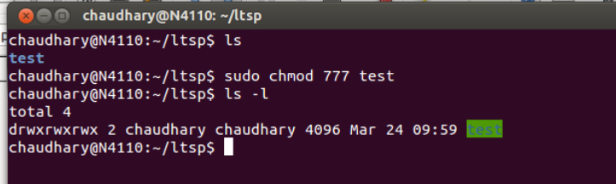

Description:

This is a directory where everyone Owner, Group or World has read, write and executable permissions.

1. **For 755**

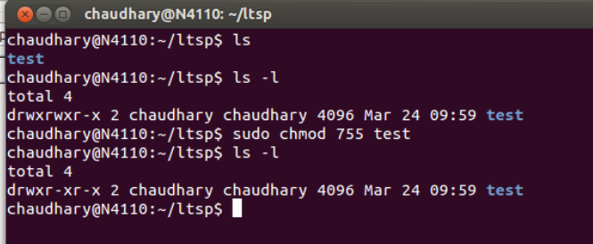

Description:

The directory can be changed only by owner however everyone else can view its contents

1. **For 600**

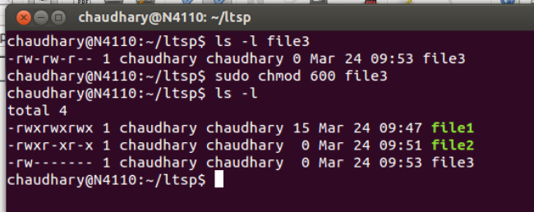

Description:

Owner has read and write permission

1. **For Chmod 700**

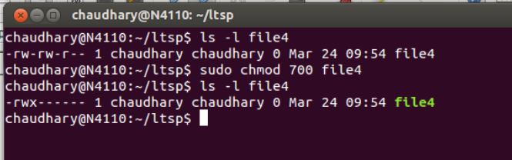

**Description :**

Owner has read, write and execute permissions. Best combinations for programmers or executables that the owner wishes to run.

Chmod also supports a symbolic notation for specifying file modes. Symbolic notation is divided into three parts: who the change will affect , which operation will be performed, and what permission will be set. To specify who is affected, a combination of the characters “u”, “g”, “a“ is used as follows

Symbol Meaning

**u** Short for “user” but means the file or directory owner

**g**  Group owner

**o** Short for “others”, but means world

**a** Short for “all” The combination of “u”, ”g”, ”o”

**Some examples of symbolic Notation.**

Notation Meaning

**u + x**  Add executable permission for the owner

**u – x**  Remove execute permission from the owner

**+x** Add execute permission for the owner, group, and world equivalent to a+x

**o-rw**  Remove all the read permission from anyone besides the owner and group owner

**go=rw**  Set the group owner and anyone besides the owner to have read and write permission. If either the group owner or world previously had execute permissions, they are removed

**u+x,go=rx** Add execute permission for the owner and set the permission for the group and others to read and execute. Multiple specifications may be separated by commas,

**Few Combined examples are:**

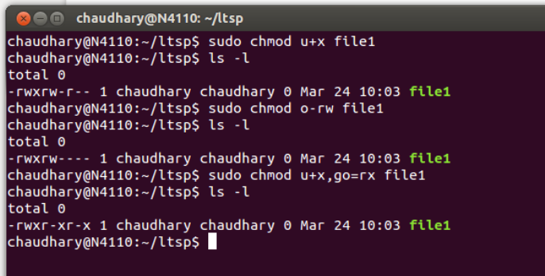

1. **chown : Changing Ownership**

The chown command allows you to change the ownership of a file to someone else. Only the root user can do this. (Normal users may not give away file ownership or steal own-ership from another user.) The syntax of the command is as follows:

ltsp1@N4110:~$ **chown [-R] username filename**

Where **username** is the login of the user to whom you want to assign ownership, and **filename** is the name of the file in question. The filename may be a directory as well. The –R option applies when the specified filename is a directory name. This option tell the command to recursively descend through the directory tree and apply the new ownership, not only to the directory itself, but also to all the files and directories within it.

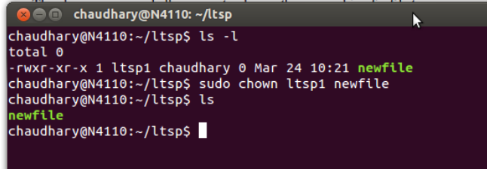

1. **Chgrp: Changing group.**

It works same as the chown . The syntax is given below:

ltsp2@N4110:~$ **chgrp [-R] username filename**

1. **su : Run shell with substitute user and group Ids**

The su command is used to start a shell as another user. Often we want to gain superuser privileges to carry out some administrative task and it is possible to “become” another regular user for such things as testing & maintainance of the system. Also to gain access to sudo user account, an account holder must have sudo privilege in the /etc/sudoers file list.

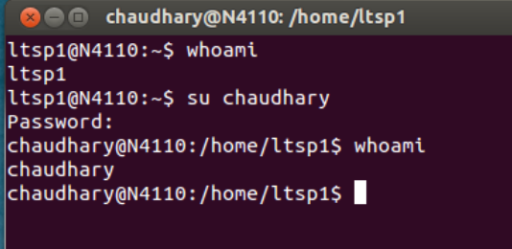

**User Modification in the System.**

**Adding users.**

**For adding users use *adduser* commnad**

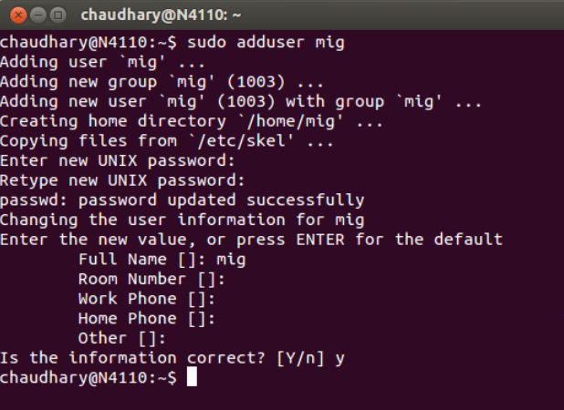

**For removing the user use deluser**

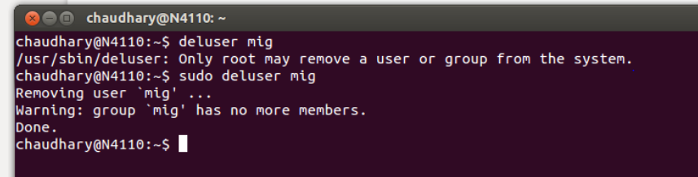

You can also use graphical tool called ***gnome-system-tools*** for adding the users graphically in the system. This tools can be installed by using command line

**sudo ap-get install gnome-system-tools**

**Changing the password. (** Changing password of ***mig*** user in the system**)**

sudo passwd mig

**Set up Thin client Admin user**

sudo -s -H

chroot /opt/ltsp/i386

useradd -m **adminname** -G sudo

passwd **adminname**

exit

exit

**Now lock the admin account’s password**

sudo chroot /opt/ltsp/i386 passwd -l adminname

**Finally Update the sshkeys and images by following commands**

sudo ltsp-update-sshkeys

sudo ltsp-update-image –arch i386

**Commands and tools for managing ltsp contents.**

**Local app installation**

Local app short form of local application is designed to reduce the server load and transfer the some of the processing responsibility to the thin-client device. Local app allows us to utilize the thin-client memory to store application and thin-client processors to run these application. When application is local app, it is consuming significantly less server resources as compared to the server based application. Utilizing local apps also reduces local area Network traffic created by an ltsp deployment. Follow the below procedure to install local apps in the system.

# Fist copy the sources list from your server to ltsp package folder as sources for file downloads # are not defined in the ltsp package souces.list and you must be login as root user for ltsp #environment.

less /etc/apt/sources.list

less /opt/ltsp/i386/etc/apt/sources.list

cp /etc/apt/souces.list /opt/ltsp/i386/etc/apt/souces.list

EXPORT_LTSP_HANDLE_DAEMONS=false

#Now login as a ltsp root user

sudo chroot /otp/ltsp/i386

mount -t proc proc /proc

apt-get update

apt-get dist-upgrade

apt-get install “what_ever_you_wnat_to_install”

#exit to server

exit

sudo ltsp-update-kernels

sudo unmount /opt/ltsp/i386/proc/ #if this line doesn't work

sudo unmount -l /opt/lstp/i386/proc #use this line

sudo ltsp-update-sshkeys

sudo ltsp-update-image --arch i386

**For direct installation/removable in the server**

sudo apt-get update

sudo apt-get install *package name*

Sudo apt-get remove *package name*

(You can also use Ubuntu software center for installation or removable of applications)

**Commands and Tools for managing ltsp contents**

**Limiting application acess to thin clients**

This can be done by using inbuilt graphical tool called ***alacarte***  on command line from thin client user type alacarte on terminal.

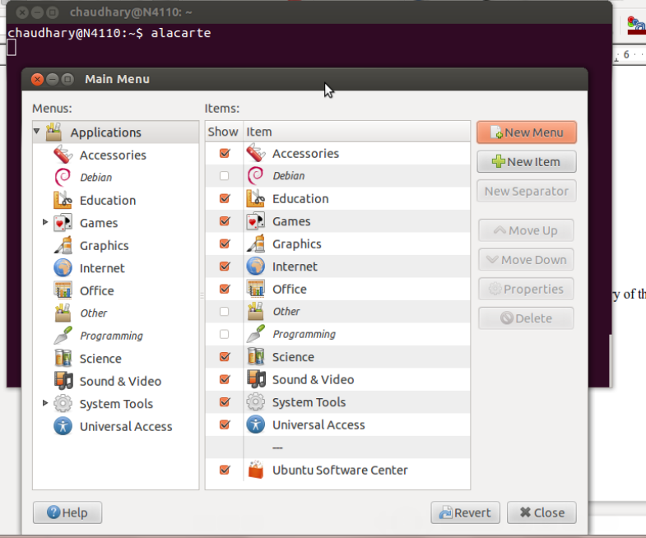

**Commands and tools related to networks**  
View your DHCP server is runnig properly or not.

sudo service isc-dhcp-server status

Sudo service isc-dhcp-server start/restart/stop

Sudo service network-manager restart

The output should match as described in below figure however the processes might differ in your system.

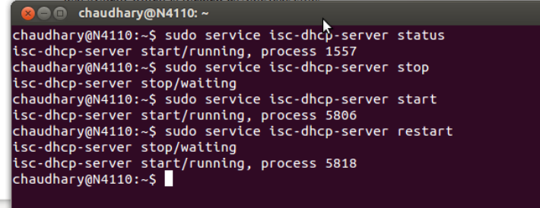

**Restart your network manager by following command**

sudo /etc/init.d/networking restart

**For viewing Ip and Macadress use**

ifconfig

ifconfig –a

**For making interfaces (on/off) or up/down**

sudo ifconfig eth0 down

sudo ifconfig eth0 up

**To check the conection on eth0 interface is ok or not.**

sudo mii-tool eth0

ping #*other client user*

**To kill the misbehaved processor**

kill *PID* # Use top to list running process id.

killall -9 –l # For frozen desktop

xkill # To kill any runnig windows

When you connect multiple hard drive in the board sometime you may get network interfaces increasing like **eth0, eth1, eth2**  etc. Although there is no any harm on configuration, sometime this may create confusion. Remove such extras ethX’s.

sudo rm /etc/udev/rules.d/70-percistent-net.rules

w

**Checking the other user login activity**.

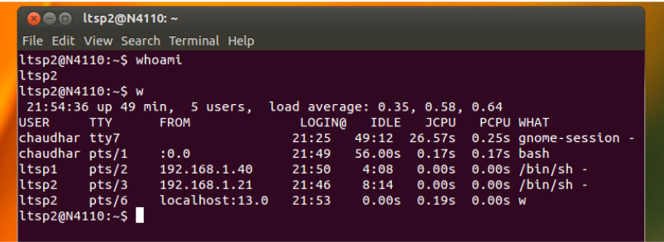

Also use GUI tool called **system-monitor** for Performance, CPU usage, Memory and Upper and Lower bounds of packet receiving and transmitting in the system.

**Checking the physical connection of clients**

Go to the network switch and observer the light of the corresponding clients. If the light is blinking then the data is being transferred else the cable might be damaged or not properly connected.

**Trobleshooting The System**

Problems are inevitable they might occur after the system being used for certain period time or if it is used in improper way. They may occur due to power cut offs, other physical interrupts and unusual modifications in the file system. It is recommended to see log files before troubleshooting the software related problems. It can be found under /opt/ltsp/i386/var/log or /var/log Some of the common problems faced in the system and their probable solutions are lsited below:

***Q.Server is running but the clients is halt in the dhcp screen ?***

A.This situation is caused when the clients is not able to get ip address from the DHCP server so further booting process can’t continue. At first we must check the network interface of the server is active or not. In terminal use the following command.

* **sudo mii-tool**

you can type exact interface to know about its conditions like ( **sudo mii-tool eth0** ) or whatever interface you are working on.

If the output have *link ok* then the interface is working well otherwise the network interface is having a problem. Then try using

* **sudo service network-manager restart**

This might do the trick and bring back the connection in the network interface.

If still the problem exits click manually to network connection icon which is at the top right corner of your panel and then click to the interface on which you configured your dhcp environment. If still problem is not solved then check whether the DHCP server is running or not type following command in the terminal

* **sudo service isc-dhcp-server start/restart/stop**

if the server is running OK check physical LAN cable connection if there is breakage/mouse bites etc. But if the server is not OK then make it runnable by configuring the file which are located at

1. **/etc/network/interfaces**
2. **/etc/ltsp/dhcpd.conf**
3. **/etc/NetworkManager/NetworkManager.conf**
4. **/etc/default/isc-dhcp-server**

Note: For above configuration see the below link for configuration of dchp server.

***Q.The client are not able to boot and get stuck in bios error message?***

A.This problem is caused because of the BIOS setting related the LAN boot. Please go to the BIOS setup and enable the LAN boot option. This might solve the problem. This can be done by pressing F12 in newer version while *del* button in previous version and then search for boot option.

***Q.The client display media test failure ?***

Ans : This problem is due to the fault in network cable or improper connection of the network cable between the network switch and client. So, please check the cable connection and if it doesn’t work replace the network cable with appropriate wiring combination. Use standard combination. Use straight wire combination (Straight wires are used to connect two different devices in our case Switch-X-terminal, ). Combinations are

(From left to right direction by facing RJ-45 metallic part upwards )

1. **White Orange**
2. **Orange**
3. **White Green**
4. **Blue**
5. **White Blue**
6. **Green**
7. **White Brown**
8. **Brown**

***Q. The clients are not able to log-in through the login screen?***

A. This problem might be caused due to the updating the ltps image file using *ltsp-image-update.* It can be solved by first updating the ssh keys then updating the ltsp image.Use below commands

* sudo ltsp-update-ssh keys
* sudo ltsp-update-image –arch i386

***Q.Clients are not able to boot showing ARP time out***

A.The problem might occur if the *ups* is placed too close to the cat-cable causing interference. Keep *ups* to certain distance from the cat-cable.

***Q.Clients / Server reboot during shutdown option***

A. This might occur due to active service running behind the server. At first shutdown clients properly and then shutdown server. If still can’t shutdown use

**sudo poweroff**

***Q.Tearing of screen occurs when you first configure your ltsp environment in the LAPTOP***

A. The reason is unsupport of 3d graphics on the thin clients, so the problem can be solved by login as “***GNOME classic (no effects****)*”. This can be done by clicking ubuntu icon before password typing in the box.

**Some Few Optional Tweek and Trick for maintenance**

**Disabling speakers**

PC speakers can be very annoying, especially upon login when users attempt to use the numeric keypad and the num lock they isn’t enabled, causing a system beep. So this section depicts how to disable the pc speakers on ltsp system

We can disable LTSP client PC speakers by creating a file that will blacklist the pc speaker kernel module from loading upon thin-client boot up.

First, create a file: /opt/ltsp/i386/etc/modprobe.d/blacklist-pcspkr.conf:

sudo vi /opt/ltsp/arch/etc/modprobe.d/blacklist-pcspkr.conf

blacklist-pcspkr.conf:

# Blacklists PC Speaker module (pcspkr)

blacklist pcspkr

Update the client chroot image:

sudo ltsp-update-image –arch i386

Reboot thin-clients, and enjoy a beepless LTSP environment.

**Some Basic Commands usefull for troubleshooting**

* Knowing about the system’s information (On Terminal)

**lsb_release -a**

* Knowing about the system’s hardware

**lspci**

* Knowing system is 32/64 bit os

**uname –m or uname –r**

(Note 86 is for 32 bit while 64 is for 64 bit os)

* Knowing who is the current user

**whoami**

* Finding appropriate file’s location

**locate *filename*** or use **find** command see manual page for more information.

* Finding appropriate path/location of the installed file in the system.

**whereis *klavaro* #**Klavaro is installed app in the system.

* Knowing the application is installed or not in the system

**dpkg –l *applicaion_name***

* Greeping text from large file text files

**ls | grep –i “*string”*** #See manual page for more information ie type **man *grep***

**ls | grep *“string”* *filename***

* To search for related guessed command in the system.

**appropos *guessed_word***

Example: If i don’t know how to copy the files in the unix system we can use abreviation like, it will show the related information about the copy command in the system.

**appropos copy/cut**

For Dhcp configuration for LTSP in the ubuntu see the below links.

<https://www.thefanclub.co.za/how-to/how-create-ubuntu-1104-x64-ltsp-server-32bit-thin-clients>

<http://www.havetheknowhow.com/Configure-the-server/Install-LTSP.html>

manual by mig